Project Design Phase-II
Data Flow Diagram & User Stories

Date | 06/02/2026
Team ID | LTVIP2026TMIDS83275
Project Name | Deep Learning Fundus Image Analysis for Early Detection of Diabetic Retinopathy
Maximum Marks | 4 Marks

Data Flow Diagrams:
A Data Flow Diagram (DFD) is a traditional visual representation of the information flows within a system. A neat and clear DFD can depict the right amount of the system requirement graphically. It shows how data enters and leaves the system, what changes the information, and where data is stored.
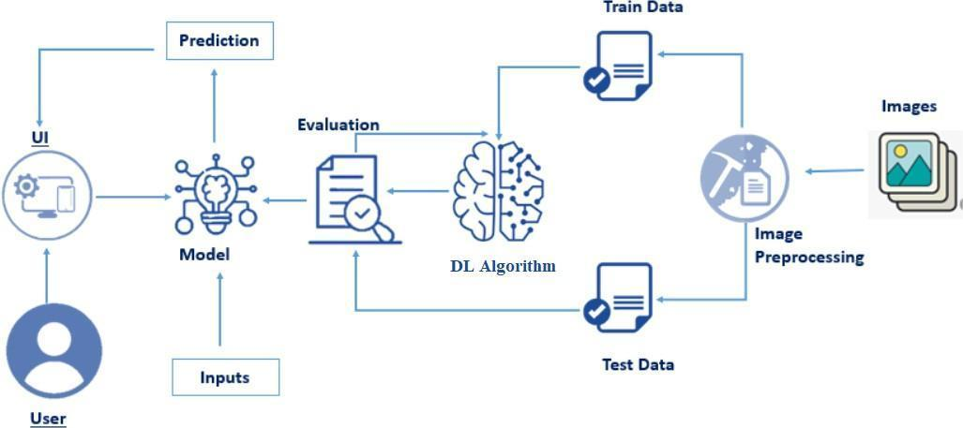

User Stories

User Type | Functional Requirement (Epic) | User Story Number | User Story / Task | Acceptance Criteria | Priority | Release
Customer (Web User – Patient) | Image Upload | USN-1 | As a user, I can upload a retinal fundus image for analysis | I can successfully upload image and see preview | High | Sprint-1
 | Image Validation | USN-2 | As a user, I can upload only valid image formats (jpg/png) | System rejects invalid file formats with error message | High | Sprint-1
 | Prediction | USN-3 | As a user, I can get diabetic retinopathy severity prediction after uploading image | System displays predicted class (No DR / Mild / Moderate / Severe / Proliferative) | High | Sprint-1
 | Result Display | USN-4 | As a user, I can clearly view my prediction result on screen | Result page loads with prediction label | High | Sprint-1
 | Error Handling | USN-5 | As a user, I receive an error message if prediction fails | Proper error message displayed | Medium | Sprint-1
 | Multiple Uploads | USN-6 | As a user, I can upload and test multiple images | System allows repeated uploads without crashing | Medium | Sprint-2
Ophthalmologist (Medical User) | Screening Assistance | USN-7 | As a doctor, I can use the system to assist in early screening of DR | System provides severity classification quickly | High | Sprint-1
 | Accuracy Support | USN-8 | As a doctor, I want reliable predictions to support diagnosis | Model accuracy above acceptable threshold (>85%) | High | Sprint-2
 | Efficiency | USN-9 | As a doctor, I can analyze multiple patient images quickly | System processes images in under 3 seconds | Medium | Sprint-2
Administrator | System Monitoring | USN-10 | As an admin, I can ensure the ML model loads correctly | System starts without model loading errors | High | Sprint-1
 | Deployment | USN-11 | As an admin, I can deploy the system to cloud platform | Application accessible via public URL | Medium | Sprint-2
 | Maintenance | USN-12 | As an admin, I can update the trained model if accuracy improves | New model can replace old model without system crash | Medium | Sprint-3
Customer | Report Generation | USN-13 | As a user, I can download a prediction report | PDF report generated successfully | Low | Sprint-3
Customer | Cloud Access | USN-14 | As a user, I can access the system online | App accessible via browser globally | Medium | Sprint-2

B. Data Flow Diagram (Level 0 – Context Diagram)
User
↓
Web Interface (Flask Application)
↓
Deep Learning Model
↓
Prediction Result
↓
User
C. Level 1 DFD
- User uploads image
- Image preprocessing module processes image
- Model prediction module generates classification
- Result displayed on webpage
Architecture Diagram (Professional Format)
┌────────────────────┐
│ User Browser │
│ (Upload Fundus Img) │
└─────────┬──────────┘
│ HTTP Request
┌────────────────────┐
│ Flask Web Server │
│ (app.py) │
└─────────┬──────────┘
│
│ Calls
┌────────────────────┐
│ Image Processing │
│ Resize + Normalize │
└─────────┬──────────┘
│ Input Tensor
┌────────────────────┐
│ Deep Learning CNN │
│ (Trained Model) │
└───────── | ──────────
│ Prediction
┌────────────────────┐
│ Result Rendering │
│ (HTML Output) |
└────────────────────┘

